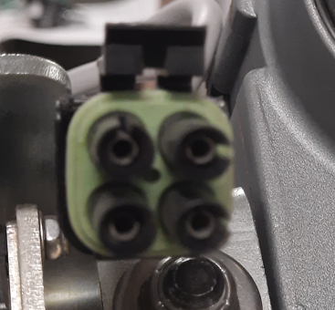

Connector clip on actuator 2 pins on same side as locator clip 12V or above should run/test actuator

